Manual No.-17

Such other information as may be prescribed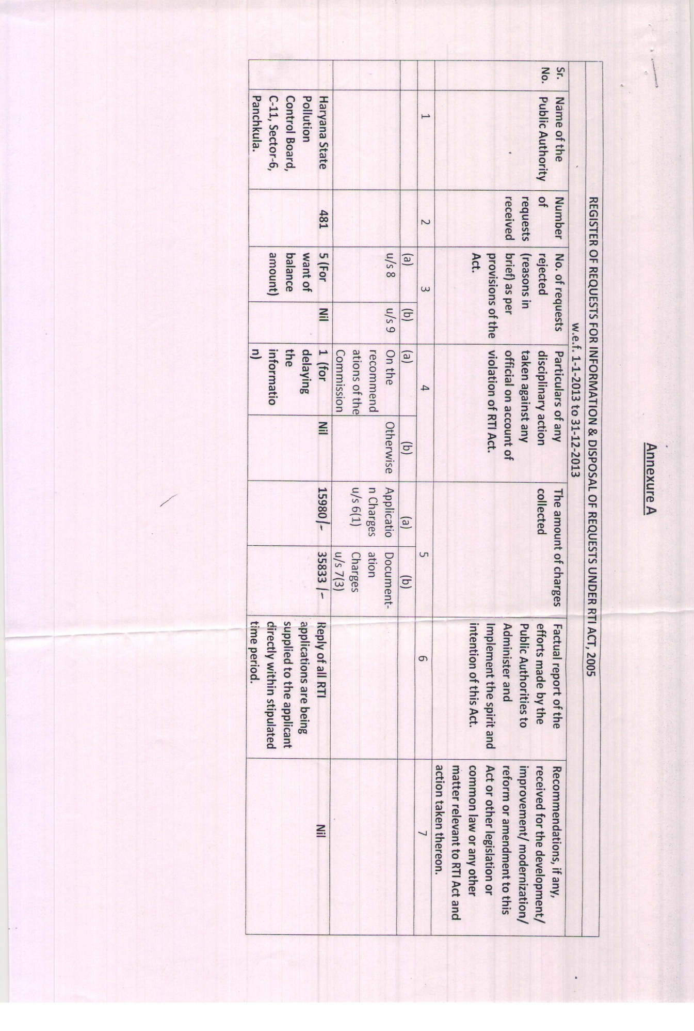

List of office building constructed by the Board through the Government agency.

Sr. No. | Name and Address of the building | Name of the agency
1. | Haryana State Pollution Control Board, C-11, Sec-6, Panchkula | National Building Construction Corporation Ltd (A Government of India Enterprise) Chandigarh Zone, SCO-111-112, 4th floor, Sec-34A, Chandigarh
2. | Regional Office, Haryana State Pollution Control Board, Faridabad and Ballabgarh Region, Sec-16A, Opp. Hewa Appartment, Faridabad | National Building Construction Corporation Ltd (A Government of India Enterprise) Chandigarh Zone, SCO
3. | Regional Office, Haryana State Pollution Control Board, Hisar Region and Laboratory, Near Vishwas Secondary school, E-II, Hisar | National Building Construction Corporation Ltd (A Government of India Enterprise) Chandigarh Zone, SCO

